**JAYPEE INSTITUTE OF INFORMATION TECHNOLOGY**

**Indian Constitution and Traditional Knowledge Report**

**RIGHT TO PRIVACY**horizontal line

**SEMESTER : 5th SEMESTER**

**BRANCH : INFORMATION TECHNOLOGY**

**BATCH : B-11**

**CASE : RIGHT TO PRIVACY (2007)**

**FACULTY NAME : MS. CHANDRIMA CHAUDHARI**

**COURSE CODE : 18HS311**

**STUDENT DETAILS: AMIT G. PATIL - 19104004**

**SANJOLI GOYAL - 19104007**

**MUSKAN JAIN - 19104010**

Table Of Contents

MP Sharma v. Satish Chandra(1954)

Kharak Singh v. State of Uttar Pradesh(1962)

PUCL vs UOI(1997)

Justice K.S. Puttaswamy vs UOI(2007)

From the petitioners:

Arvind Datar

From the Centre, UIDAI and various State governments:

Attorney-General K.K. Venugopal for the Centre

Additional Solicitor General Tushar Mehta for both UIDAI

Senior advocate C.A. Sundaram for Maharashtra government:

Right to Privacy - A Fundamental Right

Importance

Impact

Contribution of Team Members

References

Introduction

On *24 August 2017*, the Supreme Court of India in a historic judgement declared the right to privacy as a fundamental right protected under the Indian Constitution. In declaring that this right stems from the fundamental right to life and liberty.

A **nine-judge bench** of the Supreme Court in the case of **Puttaswamy v. Union of India** has declared that the right to privacy is a fundamental right protected under Part III of the Constitution of India. While primarily focused on the individual's right against the State for violations of their privacy, this landmark judgement will have repercussions across both State and non-State actors and will likely result in the enactment of a comprehensive law on privacy.

Background

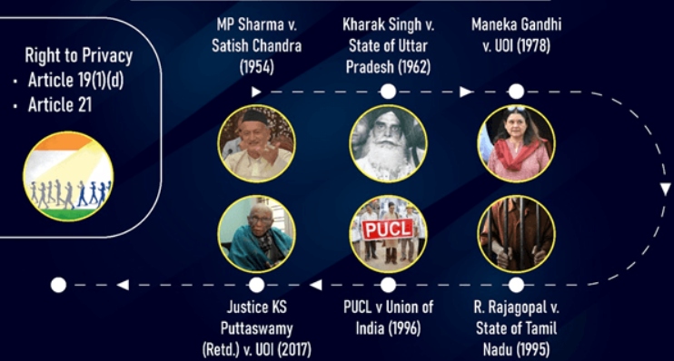

## *MP Sharma v. Satish Chandra(1954)*

This case relates to the investigation going on Dalmia Group, charges were that they were indulged in money laundering and other malpractices. And to hide it they were forging fake documents.

An FIR was filed, and under it warrants for “Search and seizure” for more than 30 locations were issued. In this process Dalmia group challenged the process saying

“That during the search along with other documents there private documents were also held under investigation, thus violating right to privacy ”

For this **eight-judge bench** said

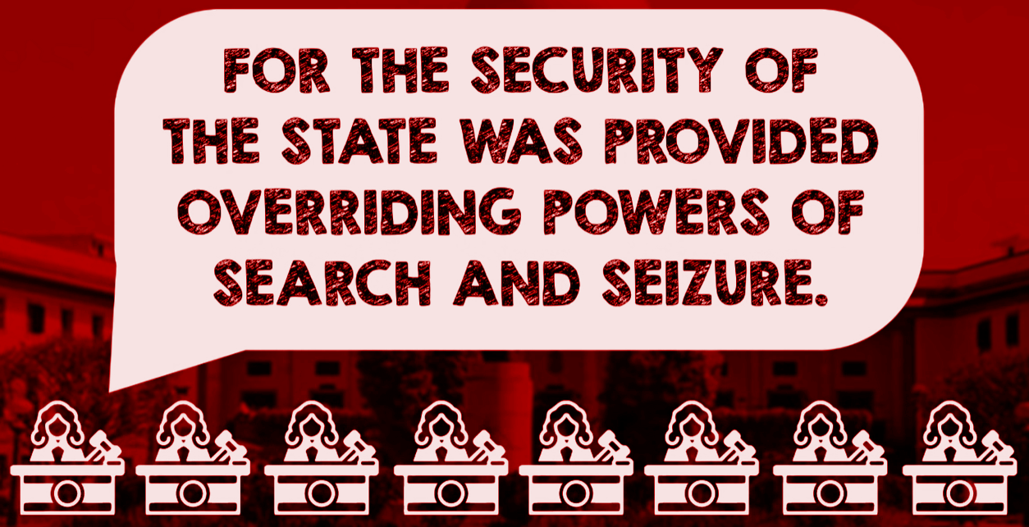

And it was mentioned that **there is no fundamental right to privacy.**

*MP Sharma* dealt with the right against self-incrimination and, while it did mention the right to privacy in passing, it was clear that these comments were stray observations at best.

## *Kharak Singh v. State of Uttar Pradesh(1962)*

In this case Kharak Singh was arrested for the offence of “Dacoity” but due to lack of substantial evidence he was released.

For investigation purpose the UP police decided to incorporate surveillance under UP Police Regulation, under which

* Anyone that visits the person under surveillance is a potential suspect.
* Domiciliary visits i.e visiting that person’s private property anytime under authority.
* Tracking their movements

Kharak Singh, fed up with the surveillance, decided to file a petition challenging the validity of surveillance and UP police Regulation saying that due to the surveillance his right to movement and right to life and personal liberty was violated.

In response to that **six-judge bench said,**

There is no right to privacy and right to movement if infringed only when there is physical restrictions and,

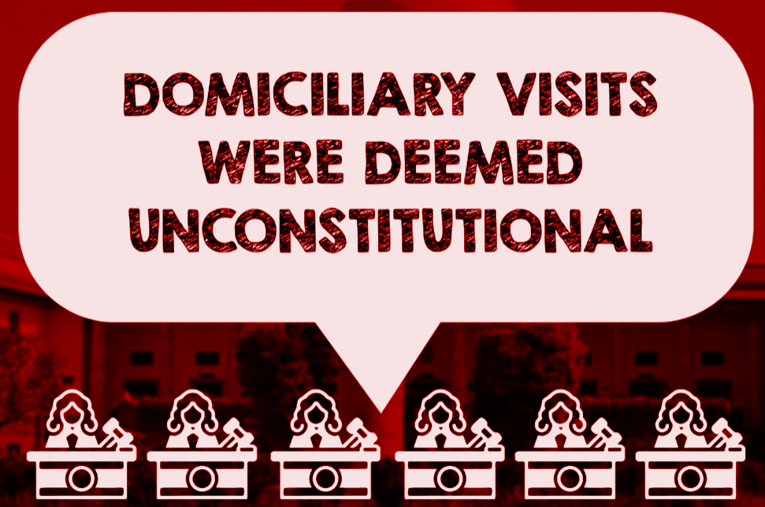

Although the minority opinion of Justice Subba Rao, which was majority opinion later was important, he said-

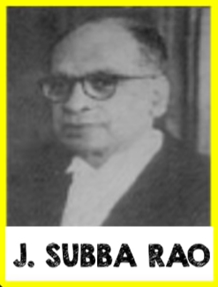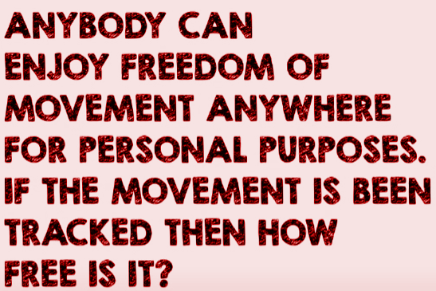

In the subsequent case of Gobind v. State of Madhya Pradesh, a three-judge bench, and R. Rajgolpala vs UOI, started giving recognition to Right to Privacy as well.

## *PUCL vs UOI(1997)*

Also known as Wiretapping Case.Former Prime minister Chandra Shekhar alleged th GOI that the government is tapping his phone along with 27 more politicians.And when the CBI deemed the allegations to be true, the PUCL filed a PIL, that the supreme court should clarify the laws relating to wiretapping and phone tappings.

Indian Telegraph Act Section 5(2) was challenged in this case.

Certain clarifications were made-

* The Right to Privacy will be covered under Right to life and personal liberty(Article 21)
* Telephonic Conversations are also under Right to Privacy
* Indian Telegraph Act - Rule 4/9(A) was co-defined i.e. wiretapping can only be done under unavoidable circumstances

## *Justice K.S. Puttaswamy vs UOI(2007)*

Also known as the Aadhar case.

The judgement was pronounced in response to a reference made in connection with the legal challenge to India's national identity project – Aadhaar – during which the Advocate General of India(AGI) argued that the Indian Constitution does not include within it a fundamental right to privacy. His arguments were based on above top two cases decided by the Supreme Court -

A **Nine-judge bench** gave a unanimous decision saying-

* Indians do have a Fundamental Right to Privacy
* Article 21 supports it, no separate declaration needed
* Article 14, 19 and 21 sufficiently protects them

Arguments

## From the petitioners:

**Shyam Divan**

Divan was the first counsel to start the arguments on behalf of the petitioners. His arguments challenged the Aadhaar programme, the Aadhaar Act, 2016 and related entities. He argued:

* The Aadhaar architecture is capable of tracking, tagging and profiling of individuals and, hence, it is unconstitutional.
* Section 57 of the Aadhaar Act extends the Aadhaar platform to government and private bodies, which makes it capable of turning into a surveillance state.

**Kapil Sibal**

* In light of the judgement in Right to Privacy, aggregation of sensitive personal information of individuals cannot be allowed.
* There is no concept of consent in the Aadhaar Act and it is only ‘illusory’ as without Aadhaar authentication a person will be denied benefits, services and subsidies.
* Aadhaar violates informational privacy which has been recognised by the judgement in Right to Privacy case.
* Aadhaar fundamentally violates the balance between the citizen and the state.
* In absence of any “compelling state interest”, the collection of information of citizens violates Article 14 of the Constitution.

### **Arvind Datar**

* Linking of bank accounts with Aadhaar violates rights of a citizen guaranteed under Article 14 and 21 as they cannot operate accounts without linking it with the unique ID.
* There is no valid reason provided for the linking of bank accounts with Aadhaar.
* Aadhaar will destroy decisional autonomy (right of choice) which has been recognised in the Right to Privacy judgement.
* The Supreme Court judgement in Section 139AA of Income Tax Act, which mandates linking of Aadhaar, needs to be re-looked after the Right to Privacy judgement.

## From the Centre, UIDAI and various State governments:

### Attorney-General K.K. Venugopal for the Centre

* Some citizens cannot agitate against Aadhaar, saying it is a violation of their right to privacy. An elite few cannot claim that their bodily integrity would be violated by a scheme which serves to bring home basic human rights and social justice to millions of poor households across the country.

### Additional Solicitor General Tushar Mehta for both UIDAI

* What is so great about my fingerprints? I touch a file, I leave my fingerprints. These are all perceived ideas of privacy. We should aim to use technology to the maximum for the betterment of human beings.
* Aadhaar has 115.15 crore people enrolled, that is 98% of the population. Privacy is non-negotiable, confidentiality is non-negotiable under the Aadhaar Act. Privacy cannot be inserted as a new fundamental right into the Constitution.

### **Senior advocate C.A. Sundaram for Maharashtra government:**

* Privacy is not a fundamental right but only a "concept". Constitution makers had considered and rejected the idea of privacy as a fundamental right. For something to be a fundamental right, it has to be tangible and exact.
* Privacy has no exactitude, in fact, the concept of privacy varies from person to person. If made a fundamental right, it would open a flood of litigation.

Judgements

### *Right to Privacy - A Fundamental Right*

The Supreme Court confirmed that the **right to privacy is a fundamental right that does not need to be separately articulated but can be derived from Articles 14, 19 and 21 of the Constitution of India.** It is a natural right that subsists as an integral part to the right to life and liberty. It is a fundamental and inalienable right and attaches to the person covering all information about that person and the choices that he/ she makes. It protects an individual from the scrutiny of the State in their home, of their movements and over their reproductive choices, choice of partners, food habits, etc. Therefore, any action by the State that results in an infringement of the right to privacy is subject to judicial review.

Importance and Impact

## Importance

1. Privacy rights prevent the government from spying on people (without cause) i.e unnecessary intervention
2. Privacy rights protects the citizens from state, journalists or any other fellow citizen
3. Privacy rights keep groups from using personal data for their own goals
4. Privacy rights help ensure those who steal or misuse data are held accountable
5. Privacy rights help maintain social boundaries
6. Privacy rights help build trust
7. Privacy rights ensure we have control over our data
8. Privacy rights protect freedom of speech and thought
9. Privacy rights let you engage freely in politics
10. Privacy rights protect reputations
11. Privacy rights protect your finances

## Impact

Case: Vineet Kumar Case(2019)

* Charges: The bank employs were charged of bribery and for that their phones were being tapped
* Challenge: the phone tapping was challenged in this case
* Bombay High Court Decision:
  + Phone tapping is permitted in case of public emergency and safety
  + And The threshold of this is very high
  + A small scale economic offences cannot match this threshold
  + Thus this phone tapping was deemed illegal and **infringement of Right to Privacy**

This was a single example but showed us how Right to Privacy changed the nature of how the cases are handled now vs when there was no such right.

Thus in conclusion to the impact of Right to Privacy, the decision was issued in order to set at rest an unsettled position in law that had a bearing on a number of cases currently before various courts of the land.

It is also clear, given the express directions of the Supreme Court in this regard, that the government is likely to enact a comprehensive privacy law based on the recommendations of the Justice Srikrishna committee. With this, the privacy obligations of corporations towards their customers and employees is likely to be clarified and a new regime for the protection of personal privacy established.

Contribution of team members

1. Amit Patil (19104004)
   1. Studying key arguments and articulating them in Aadhar case
   2. Study on *MP Sharma v. Satish Chandra(1954)*
   3. Preparation of Slides and Presentation on Arguments of Aadhar case
2. Sanjoli Goyal (19104007)
   1. Researching, aggregating and documenting related cases and their verdicts
   2. Study on *PUCL vs UOI(1997)*
   3. Finding importance of *Right to Privacy*
   4. Preparation of Slides and Presentation on Importance and Impact of Right to Privacy
3. Muskan Jain (19104010)
   1. Finding reference docs and verifying authenticity of the resources
   2. Study on *Kharak Singh v. State of Uttar Pradesh(1962)*
   3. Finding Impact of *Right to Privacy*
   4. Preparation of Slides and Presentation on related cases studies and background

References

1.[10 Reasons Why Privacy Rights are Important - Human Rights Careers](https://www.humanrightscareers.com/issues/reasons-why-privacy-rights-are-important/)

2.[Supreme Court Declares Right To Privacy A Fundamental Right - Privacy - India (mondaq.com)](https://www.mondaq.com/india/privacy-protection/625192/supreme-court-declares-right-to-privacy-a-fundamental-right)

3.[Judgment of the Court in Plain English (I) - Supreme Court Observer (scobserver.in)](https://www.scobserver.in/reports/k-s-puttaswamy-right-to-privacy-judgment-of-the-court-in-plain-english-i/)  
4.<https://www.thehindu.com/news/national/major-arguments-in-the-right-to-privacy-case/article19551038.ece>

5.<https://blog.finology.in/constitutional-developments/analysis-of-right-to-privacy-india>